This Section is filled by The Author

PLEASE FILL THE FORM BELOW AND DO NOT REMOVE THIS FROM MANUSCRIPT

Authors Submission Checklist
All manuscripts must meet the following criteria to be processed into the peer-review stage. Failure to meet the following criteria may increase the processing time of the manuscript or even rejection.
Write OK if the authors have confirmed that the manuscript meets the criteria. If the author cannot fulfill these criteria, give a reason, and write in the checklist with highlighted text.

1 | Template and Layout | Authors Claim &  Comment | Editors Comment
1.1 | Have used the latest SinkrOn template (latest update June, 2021) | √
1.2 | Introduction, Literature Review Methods, Result, Discussion, and  Conclusion are written in a separate section.
1.3 | Not using Bullet / Numbering in the manuscript text.
1.4 | The length of the text is between 6 and 12 pages.
2 | Title and Authors Information
2.1 | The title is written briefly, describing the contents and contributions of the manuscript. The title also does not use abbreviations or acronyms except the standard ones. The title consists of a maximum of 14 words.
2.2 | All authors have been written in the manuscript and also in the OJS system.  One of the authors who corresponded through the OJS system was determined as the correspondence authors.
2.3 | All authors must include e-mails in the manuscript and the OJS system.
2.4 | Affiliation information is written in 1 line in the text, at least showing the name of the institution and country. Full Address information should be  written in 1 line bellow affiliation information.
2.5 | The title of the manuscript is written using 'Capitalize Each Word', except  conjunctions using lowercase.
2.6 | The place and time of research do not need to be included in the title unless  the research is specific to a particular time and place.
3 | Abstracts and Keywords
3.1 | Abstract consists of 200 to a maximum of 250 words.
3.2 | Abstracts are arranged in a structured manner. Consisting of Background,  Objective, Methods, Results, and Conclusion
3.3 | The number of keywords minimal 5 words
3.4 | All keywords must be written in the abstract.
3.5 | Keywords are arranged in alphabetical order.
3.6 | A combination of all keywords represents the content, contribution, or  purpose of the text.
3.7 | Keywords can be in the form of research subjects’ category. Avoid using  adjectives as keywords in the text.
4 | Introduction
4.1 | Has explained the context/object of research and must focus following the  scope of the title.
4.2 | Has explained why this research is important.
4.3 | It has included the existing research gap, explaining the unique differences  between this study compared to similar previous studies.
4.4 | Has written research objectives/contributions explicitly.
4.5 | The length of this section is between 300 – 700 words.
5 | Literature Review
5.1 | This section is optional. This section may only be available if the explanation related to previous research is not sufficient if it is only shown  in the introduction. If this section exists, you must cite at least 6 recent papers that are closely related to the title of the paper.
6 | Methods
6.1 | Has cited a source who helped the authors in the selection of methods.
6.2 | Has explained how data is obtained.
6.3 | The procedure has been written chronologically and clearly.
6.4 | The authors have written how the results will be measured, tested, and  evaluated.
7 | Results
7.1 | The results of the study are written in logical sequences, according to the  research flow.
7.2 | The results of the study are presented in the form of narrative/textual, tables,  or images in the form of graphs or diagrams. Avoid displaying raw data.
8 | Discussion
8.1 | An explanation of the results and in-depth analysis has been written.
8.2 | A comparison of results with other studies has been written.
8.3 | Limitation of study or threat to validity has been written.
9 | Conclusion
9.1 | It has been explicitly written down the contribution of the manuscript and  the answers to the research questions.
10 | Acknowledgments
10.  1 | If it is funded research, information on the funders agency must be provided along with the contract number(if any).
11 | References
11.  1 | Always use automatic citation tools for managing your references. make sure that you already double-check the citation metadata, automatic citation tool usually has metadata errors. Use Mendeley to make Citation &  References/Bibliography. Use APA^{6th} Edition citation style.
11.  2 | Make sure all information related to the reference is written completely (eg Who, Where, and When). Check from the primary source for this information. write the name of the journal without abbreviations. please  include DOI if it's available.
11.  3 | Have cite a minimum of 15 references. a minimum of 80% comes from journal articles/conferences. a minimum of 80% must be published in the  last 5 years.
11.  4 | More than 50% of the references must come from credible sources. for example SinkrOn, ScienceDirect, IEEE Explorer, ACM Digital Library,  Springer Link, Scopus, Clarivate Analytics, and Indonesian national accredited journals (SINTA 1/2).
12 | Tables and Figures
12.  1 | Already using the appropriate format in displaying images and tables.
12.  2 | The image or graph must be self-explanatory, so it does not depend on the  text.
12.  3 | The minimum image resolution is not specified, but must be visible when  published online (colored) or printed (black and white).
12.  4 | Images do not have copyright issues.
12.  5 | All images and tables have been referenced in the manuscript.
12.  6 | The maximum number of images and tables is respectively 6. giving the reason to the editor if you need to display more than the recommended  amount.
12 | Languages
12.  1 | There are no spelling mistakes, typos, and grammatical errors. You can use tools such as Grammarly or recommendations provided by MS Word for  language checking.
12.  2 | Use direct and short sentences. Long sentences do not make writing more  professional; they only confuse readers.
This Section is filled by The Author
PLEASE FILL THE FORM BELOW AND DO NOT REMOVE THIS FROM MANUSCRIPT

OUTLINING HOW THE ISSUES ARE ADDRESSED

Title of paper:

- Address all the concerns/recommendations of the reviewers.
- All amendments made are to be highlighted in yellow color in the revised paper.

Reviewer # 1

Final Recommendation (choose one according to the reviewer's comments and cross unnecessary) :
Accepted without modification Accepted with minor corrections Accepted with major modification Rejected

Comments | Addresse d (Y/N) | Reply/Action taken
(Please add more rows if needed)

Reviewer # 2

Final Recommendation (choose one according to the reviewer's comments and cross unnecessary) :
Accepted without modification Accepted with minor corrections Accepted with major modification Rejected

Comments | Addresse d (Y/N) | Reply/Action taken

Reviewer # 3

Final Recommendation (choose one according to the reviewer's comments and cross unnecessary) :
Accepted without modification Accepted with minor corrections Accepted with major modification Rejected

Comments | Addresse d (Y/N) | Reply/Action taken

Title Using Times New Roman Regular Font with 24 pts and maximal 12Words

Author^{1)*}, Author²⁾, Author³⁾, Author⁴⁾, Author⁵⁾
¹⁾²⁾³⁾Affiliation, ⁴Affiliation, Country, ⁵Affiliation, Country
¹⁾email@email.com, ²⁾email@email.com, ³⁾email@email.com, ⁴⁾email@email.com, ⁵⁾email@email.com

Submitted :xxxxx | Accepted : xxxx | Published : xxxxx

Abstract:Abstracts are written in one paragraph consisting of 200 to 250 words. The abstract is a general summary of all scientific writings. The abstract must contain key elements that will be presented briefly. The background describes the most recent research you have done or some things you would like to know. You need to put forward the research objective to find out or confirm something. The practical implications of your research results can also be noted (if any). The way you find answers or solve problems can be written in research methods. In the research results section, you can present the findings that you made in your research. Finally, you can write down the conclusions of your research, whether your research is what you expected, or if further research is needed

Keywords: Component; formatting; style; styling; insert (minimal 5 words)

INTRODUCTION
This template provides authors with most of the formatting specifications needed for preparing electronic versions of their papers for SinkrOn: Jurnal dan Penelitian Teknik Informatika. The main sections (headings) include Introduction, Literature Review, Methods, Result, Discussion, and Conclusion.
In the introduction, researchers are expected to be able to explain the existing phenomena or background information such as prior work, hypotheses,problems to be discussed. This is followed by a statement of the purpose of the research issue or problem and/or set of questions you attempt to answer in your research.

LITERATURE REVIEW
A literature review is a critical, analytical summary and synthesis of the current knowledge of a topic. It should compare and relate different theories/research, findings, and so on, rather than just summarize them individually. It should also have a particular focus or theme to organize the review. In this section, the researcher can describe some of the related previous studies. Researchers can review the gaps in the research, then it can be used as a basis for research to be carried out

METHOD
In this section, each researcher is expected to be able to make the most recent contribution related to the solution to the existing problems. Researchers can also use images, diagrams, and flowcharts to explain the solutions to these problems.

RESULT
In this section, the researcher will explain the results of the research obtained. Researchers can also use images, tables, and curves to explain the results of the study. These results should present the raw data or the results after applying the techniques outlined in the methods section. The results are simply results; they do not conclude.

DISCUSSIONS
In this section, the researchers can give a simple discussion related to the results of the research trials.This section contains the author's opinion about the research results obtained. Common features of the discussion section include the comparison between measured and modeled data or comparison among various modeling methods, the results obtained to solve a specific engineering or scientific problem, and further explanation of new and significant findings

Figure
All figures should be numbered with Arabic numerals (1,2,3,….). Every figure should have a caption in the below of the figure. All photographs, schemas, graphs, and diagrams are to be referred to as figures. Line drawings should be good quality scans or true electronic output. Low-quality scans or monitor capture are not acceptable. Figures must be embedded in the text and not supplied separately. In MS word input the figures must be properly coded. The preferred format of figures is PNG and JPEG. Lettering and symbols should be clearly defined either in the caption or in a legend provided as part of the figure. Figures should be placed at the top or bottom of a page wherever possible, as close as possible to the first reference to them in the paper. Please ensure that all the figures are of 300 DPI resolutions as this will facilitate good output.
The figure number and caption should be typed below the illustration and left-justified [Note: one-line captions of length less than the column width (or full typesetting width or oblong) centered]. The artwork has no text along the side of it in the main body of the text. However, if two images fit next to each other, these may be placed next to each other to save space. For example, see Fig. 1.

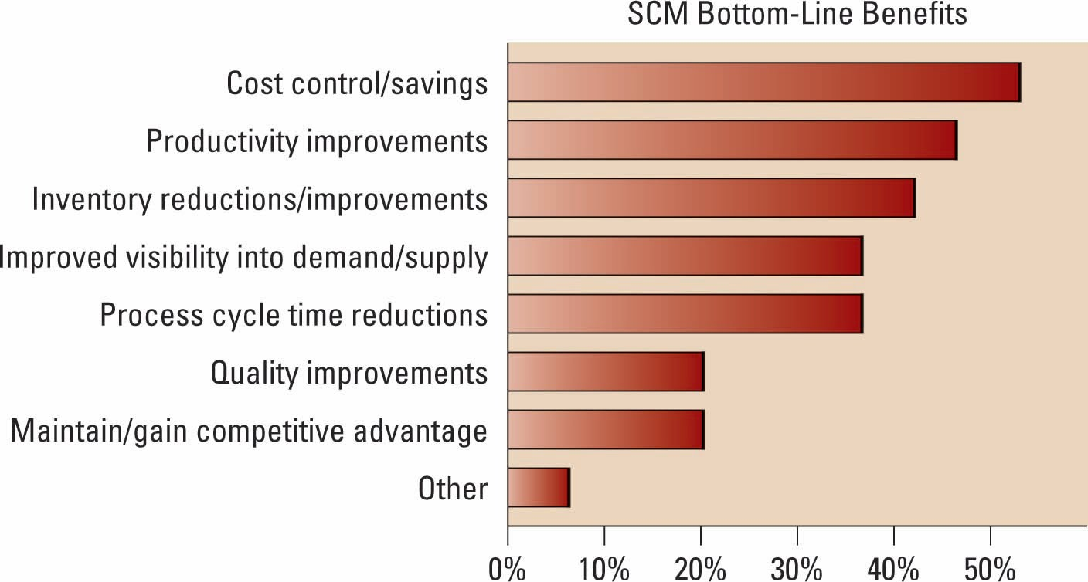
Fig. 1 Caption for figure Times New Roman 10 pt

Table
All tables should be numbered with Arabic numerals. Every table should have a caption. Headings should be placed above tables, left-justified. Only horizontal lines should be used within a table, to distinguish the column headings from the body of the table, and immediately above and below the table. Tables must be embedded in the text and not supplied separately. Table 1 is an example which the authors may find useful.

Table 1
The Significance of The Relationship in The Model
*alpha=0.05

Equations
Equations and formulae should be typed in Mathtype or any Equation Editor and numbered consecutively with Arabic numerals in parentheses on the right-hand side of the page (if referred to explicitly in the text). They should also be separated from the surrounding text by one space.
Be sure that the symbols in your equation have been defined before or immediately following the equation. Use “(1),” not “Eq. (1)” or “equation (1),” except at the beginning of a sentence: “Equation (1) is ...”

$A=πr^{2}$ (1)

CONCLUSION
The conclusion contains a summary of what is learned from the results obtained, what needs to be improved in further study. Other common features of the conclusions are the benefits and applications of the research, limitation, and recommendations based on the results obtained.

ACKNOWLEDGMENT(optional)
The acknowledgments are given at the end of the research paper and should at a minimum name the sources of funding that contributed to the article. You may also recognize other people who contributed to the article or data contained in the article but at a level of effort that does not justify their inclusion as authors. You may also state the research grant contract number if any.

REFERENCES (APA CITATION FORMATTING STYLE)
Derwing, T. M., Rossiter, M. J., & Munro, M. J. (2002). Teaching native speakers to listen to foreign-accented speech. Journal of Multilingual and Multicultural Development, 23(4), 245-259.
Krech Thomas, H. (2004). Training strategies for improving listeners' comprehension of foreign-accented speech (Doctoral dissertation). University of Colorado, Boulder.

